UNIT 2
Quantities in Chemistry
Pages 75-173

Something to Think About See page 75

Everything in the environment ..,

GETTING STARTED See page 78

Chemistry has come a long way …, (see figure 1)
In 1906 …, (see figure 2)

2.1 Amounts in Chemistry: Mass, Moles, and Molar Mass

Determining the Mass of Atoms

Isotopes and Isotopic Abundances

- Isotopes are atoms of the same element that have different number of neutrons.
- Scientists use mass number –- the total number of protons and neutrons in the nucleus – to distinguish between different isotopes of carbon.

Example: Carbon-12 and Carbon-14 are two different isotopes of carbon.
Both isotopes have 6 protons and 6 electrons, but differ in their number of neutrons.
C-12 has 6 neutrons and C-14 has 8 neutrons

- Different elements have different numbers of isotopes.
- These specific isotopes exist in different relative abundances.
- The percentage of an isotope in a sample of an element is known as the isotopic abundance. See chart below
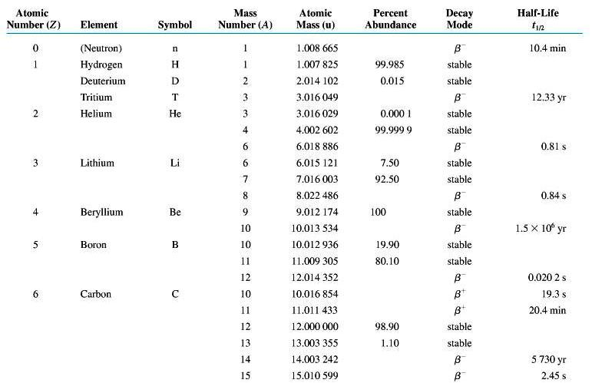
- The Atomic mass of an element is determined by calculating the weighted average of the masses of all isotopes of that element.
- Usually when an average of a set of values is calculated, you simply add up the values and divide by the number of values.
- When working with isotopes, we have to take in consideration the relative abundance of each isotope.
- See ¹ Medical Uses (PDF)
- See ² Table of Isotopic Masses and Natural Abundances (PDF)

Isotope # 1 Isotope # 2

Average atomic mass (u) =(atomic mass [u] x % abundance)+(atomic mass [u] x% abundance)+ (…,)

NOTE: % abundance(s) MUST be converted into a decimal form. Ex., 10.5% = 0.105
NOTE: Do Not Round Numbers
NOTE: Isotopes may vary from 2-? (…,)
NOTE: Check if the answer makes sense ex.,

Atomic Mass and Molecular Mass

- The atomic mass of an element is the mass of one atom of the elements, expressed in the atomic mass units or amu.
- These vales can be found on our periodic table. CHECK!
- Examples: amu of H= , amu of O= , amu of Fe=
- The molecular mass of a molecule is the mass of one molecule in atomic mass units.
- The molecular mass units are expresses in u.

- Ex., H₂O =
- Ex., CO₂ =

- Since ionic compounds are represented by formula units, the formula unit mass of an ionic compound is obtained by adding the masses of all ions in the formula unit of the compound.
- Formula units are expressed in u.

- Ex., CaCl₂
- Ex., CuSO₄

Try Practice see page 81
Questions # 1-3

The Mole and Molar Mass

How is a balanced chemical equation like a recipe?

- Consider the following equation;

H₂ + Cl₂ → 2HCl

- Hydrogen and chlorine molecules are incredibly small: too small to be seen even with a powerful microscope.
- The reaction represents an astronomically LARGE number of reacting molecules.
- Chemists can combine just the right quantities of hydrogen and chlorine so that the substances are completely used up.

How do you count entities as small as atoms and molecules?

- Counting them directly is not technically possible AND even if it were possible, there are more molecules in the flask than you could count in a lifetime.
- Therefore, chemists need a more convenient way to determine how many entities (such as atoms or molecules) are in a sample of matter.

Entity: The word “entity” is a general term used to refer to particles of matter.
Atoms, molecules, and ions are all entities that make up matter.

Using Mass to estimate Numbers

- The use of measurements such as mass to indirectly count a large number of entities has some important applications.

The Mole – A Chemist’s “Dozen”

- A dozen is a common counting unit.
- A counting unit is a convenient number that makes it easier to count objects.
- We often count doughnuts and eggs by dozens.

Give examples?

What Is a Mole?

- The mole (symbol: mol) is the SI base unit for the amount of a substance.
- One mole of a substance contains;

602 000 000 000 000 000 000 000 or 6.02 x 10 ²³ entities of the substances

- These entities could be anything from electrons and atoms to stars.
- The mole is typically used to count microscopic entities: atoms, ions, molecules, and subatomic particles such as electrons.
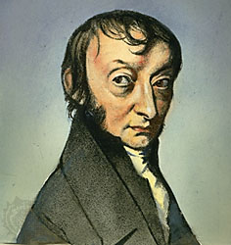
- The value 6.02 x 10 ²³ is sometimes called Avogadro’s constant (N_{A}) in honour of the Italian physicist Amedeo Avogadro (1776-1856).
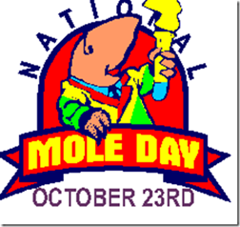

- As experimental methods improve, the value of the constant becomes more precise.

Currently N_{A} =6.022 141 99 x 10 ²³ entities.

Why chemists did not choose a more convenient number for their counting unit?

- The reason is simple, like SI base unit (metre and the kilogram); the mole is defined against a known standard.
- The standard chosen to define the mole is the number of atoms in exactly 12 g of carbon – to be more precise, in the carbon-12 isotope.
- Scientists have experimentally determined that exactly 12 g of carbon-12 contains 6.02 x 10 ²³ atoms of carbon.
- Remember that a mole is a counting unit just like a dozen.
- However, instead of counting atoms by the dozen, chemists count them by the mole.
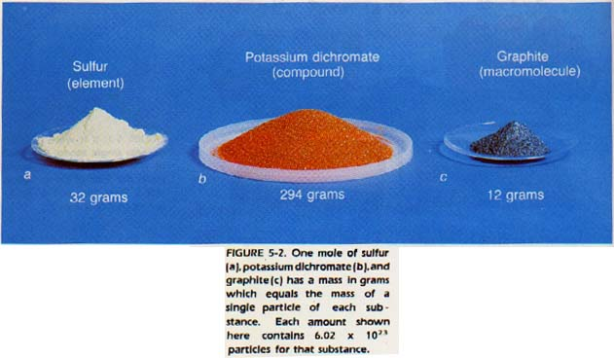
Read caption

- This can application can also work for liquids and a gas.
- Chemists use the term amount (n) as the quantity of a substance, measured in moles.
- Example; n= 1.5 mol n=1.5x10⁻⁴ mol

How Big Is a Mole (n)?

So just how much is a mole (n)? Let’s look at peas!

The Mole (n): The Green Pea Analogy

10² |  | 100 average-sized peas occupy about 25 mL.
10⁶ |  | A million peas fill an ordinary household refrigerator.
10⁹ |  | A billion peas fill a 3 bedroom house, from basement to attic.
10¹² |  | A trillion peas will fill a thousand houses, the number you would find in a medium-sized town.
10¹⁵ |  | A quadrillion peas will fill all the buildings in a city such as Hamilton.
10¹⁸ |  | A quintillion peas – suppose these is a blizzard over Alberta but – instead of snow – it snows peas.  Alberta is covered with a blanket of peas about one metre deep all the way from Saskatchewan to B.C. and all the way from the U.S. border to the N.W. Territories. The blanket of peas drifts over the roads and banks up against the sides of the houses and covers all the fields and forests. Think of flying across the province with a blanket of peas extending as far as you can see.
10²¹ |  | A sextillion – Imagine the blizzard of peas falls over the entire land of the globe – North America, South America, Europe, Asia, Africa, Australia, and Antarctica. All are covered with pea’s one metre deep.
10²³ |  | Imagine that the oceans are frozen over and the blanket of peas covers the Earth’s entire land and ocean surfaces one metre deep.  Now go out among the neighbouring stars and collect 250 planets the same size of Earth and cover each of these with a blanket of peas one metre deep.  Now you have a mole (n) of peas:  6.02 x 10 ²³

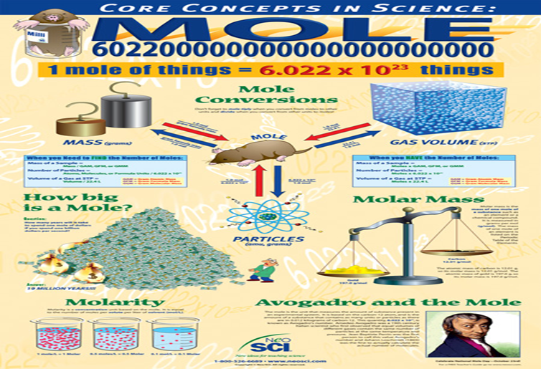

Working with Powers of 10
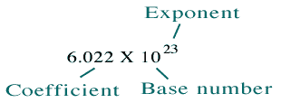

See Handout on Math Skills

Research Assignment on Avogadro Constant (Computer Lab)

http://www.brainpop.com/science/matterandchemistry/moles/

Scale of the Universe Video

The Molar Mass of Molecules and Ionic Compounds

- The production of CO₂ can be shown in the following reaction below.

C + O₂ → CO₂

- This equation tells you that 1 molecule of C reacts with every molecule of oxygen gas.
- Chemists must have a convenient method of measuring exactly the required quantities of both reactants.
- Simply combining identical masses of the two substances will not work because the atomic masses of C and O are different.
- Therefore, 1 kg of C contains a different number of molecules than 1 kg of oxygen gas.
- To get around this problem, chemists calculate the amount of each substance required (in moles).

- To do this, they must first determine the molar mass of each substance.
- The molar mass is the mass in grams of 1 mole or 6.02x10²³ entities of each substance.
- The units of molar mass are g/mol.
- Chemists often use the symbol M represent molar mass, with the chemical symbol or formula as a subscript.

Ex., M_{H2O} M_{CaSO4}

Molar Mass of Elements

- The molar mass of a monatomic element such as neon is equal to the mass given on the periodic table. Check your periodic table
- The molar mass of neon is therefore 20.18g/mol.

The Periodic Table and the Mass of Elements

- The mass of 1 mole of a monatomic element, expressed in g/mol, has the same numerical value as the average atomic mass of the element expressed in atomic mass units (u). See periodic table
- This makes finding and calculating the molar mass straight forward.
- Only one mass value need be given for each element.

The atomic mass of a carbon atom, 12.01u, has the numerical value as the mass of 1 mole of carbon, 12.01g.

- As you can see, the molar mass of carbon and the mass of 1 atom of carbon have the same numerical value.
- Remember, however, that 12.01 g/mol and 12.01 u represent very different quantities of carbon.

1 mol or 12.01 g of carbon contains 6.022x10²³ atoms – enough to fill one-quarter of a small test tube

However,

12.01u is the mass of 1 carbon atom, which is too small to be visible even with the most powerful imaging technology.

Molar Mass of Compounds

- To find the molar mass of a compound, use first need the chemical formula.
- Look up the molar masses of the elements.
- Add the molar masses of the elements, multiplying the molar mass of each element by the number of atoms of the element in the compound.

Note:
All molar masses taken from the periodic table should have 2 decimal places

Ex., C=12.01
Ex., BeO

M_{BeO} = 9.01 g/mol + 15.99 g/mol
= 25.01 g/mol

Ex., Water

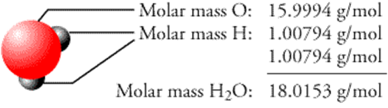

See Practice Problem Sheet on Molar Mass HO

See Relationship between Atomic Mass, Molecular Mass, and Molar Mass HO

The Molar Mass of Molecules and Ionic compounds
Try Practice see page 85
Questions # 4

REMEMBER: EVERY NUMBER needs a UNIT, AND
^{EVERY UNIT needs a NUMBER}

Calculating Involving Molar Masses

- Chemists routinely use mass (symbol: m) to measure the quantity of a chemical needed for an investigation.
- Molar mass connects mass and the number moles (n) for a substance.

Converting Mass to Amount

Number of moles = Mass
Molar mass

n = m = g = mol
M g/mol

Converting Amount to Mass

m = n x M

mass = moles x Molar mass

g = mol x g/mol

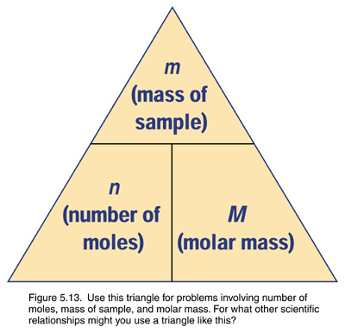
See SAMPLE problem 1/2- page 93/94
Calculating Mass from Amount in Moles

Try Practice - see page 94
Questions # 1-2
Try Practice - see page 95
Questions # 3-5

Calculating Number of Entities from Mass

How many molecules of water are there in a drop of water?

Even the smallest visible drop of water contains more molecules than you can count in a lifetime

Because molecules are so small, chemists use mass as a convenient way to estimate the number of molecules in a sample.

Determining the Number of Entities

- We often use counting units to specify a number of entities.

Converting 5 dozen doughnuts

- The number of entities in a sample, N , is determined by multiplying the amount, n, by Avogadro’s constant, N_{A;}

N= number of entities (atoms, molecules, formula units, ions)

n= # of moles

N_{A}= Avogadro constant (6.02 x10²³ atom/mole, molecule/mole, f.u/mole, ions/mole)
Depends on entity
N = n x N_{A}

Entities = mol x entities
mol

Converting Number of Particles to Moles

we know that N = n x N_{A}

therefore n = N / N_{A}

GUIDELINES

RANGE for moles (n) calculations: from x10⁻⁵ to x10⁵

Significant Digits: minimum 3 S.D’s

ex., 0.01234 = 0.0123 or 1.23x10⁻²
- ARE NOT S.D (Do Not Count)

Final Answer: = 1000 or greater USE Scientific Notation: 1.00 x 10³
0.001 or less USE Scientific Notation: 1.00 x 10⁻³

See Tutorial – Scientific Notation

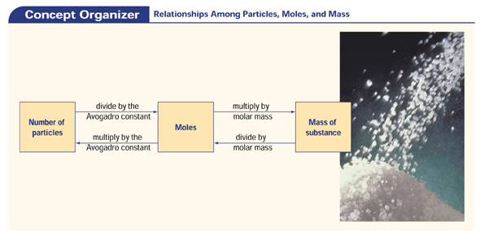

See SAMPLE problem 3 a, b
Calculating the Number and Amount of Entities – page 89-90

Try Practice - see page 91
Questions # 11-14

Try Section 2.1 Questions – see page 92
Questions # 1-10

2.2 Calculations Involving the Mole

Calculations Involving Atoms

See Sample Problem 1-8 – pages 93-104

Try Practice – pages 94-105
Questions: #1-21

Try Section 2.2 Questions – see page 106
Questions # 1-12

See WORKSHEET on Moles

And

CHALK Exercise

2.3 Determining Chemical Formulas

- In 1799, Joseph Proust, proposed the law of constant composition.
- The law states: a compound contains elements in certain fixed proportions (ratios) and in no other combinations, regardless of how the compound is prepared or where it is found in nature.
- Therefore, methane gas, CH₄ has the following ratio …,
- Therefore, water, H₂O has the following ratio …,

Something to Think About – see page 107

Since chemists cannot see …,

The Mass Spectrometer

- The mass spectrometer (see figure 2 on page 107) is used to measure the molar mass of a compound.

Something to Think About – see pages 107-108

A small sample ..,

See figures 3-4 on pages 107 and 108

The Combustion Analysis

A Combustion Analyzer is used to determine the percentage of carbon, hydrogen, oxygen, and possibly nitrogen in a compound.

Read pages 108-109
An accurately known mass …,
See figure 5 on page 109

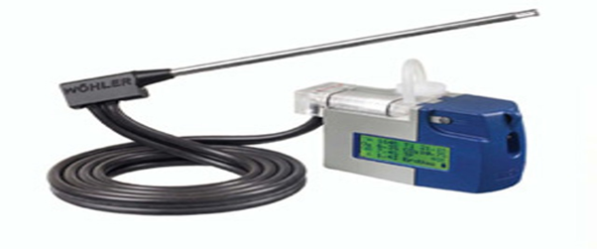

Percentage Composition

- We can determine the ratio of atoms or ions in a sample of a compound if we know the relative masses of its elements.
- With this information we can use the molar masses to convert from the relative masses to numbers of entities.
- Relative masses are usually given as percentage composition.

- Percentage composition is the percentage, by mass, of each element in the compound.

- Note that the percentage of an element(s) in a compound, do not change regardless of the mass of the original compound.
- In fact, this result is valid for all chemical compounds and is known as the law of definite proportions.
- See Table 1 on page 110

Calculating Percentage Composition by Mass

Law of Definite Proportions

The elements in a compound are always present in the same proportion by mass

Mass % of Specific Element = (Mass of Specific Element/Mass of Compound) x 100%

Possible Units for Mass;

m = grams (g), kilograms (kg), micrograms (µg), milligrams (mg)

1000g = 1kg or 1g = 1,000,000 µg (10⁶) or 1000mg = 1g
------------------------------------------------
¹ MAKE SURE BOTH UNITS ARE THE SAME ex., g/g
² NO STANDARD UNITS REQUIRED ex., g/g or kg/kg
-----------------------------------------------
¹ If No masses are given, you must use Atomic Mass (u) [Two decimal places ex., 1.51u]
² Mass % of Specific Element - Two decimal places! [ex., 20.14%]
Calculating percentage Composition by Mass
See Sample Problem 3 – pages 118-119
Try Practice – pages 119
Questions: # 7
Determining the Empirical Formula

- Percentage composition gives the percentage, by mass, of the elements in a compound.
- However, many compounds have the same percentage composition.

Ex., Formaldehyde, CH₂O, and acetic acid, C₂H₄O₂, for example, both contain 40% carbon, 6.7% hydrogen, and 53.3% oxygen, by mass.
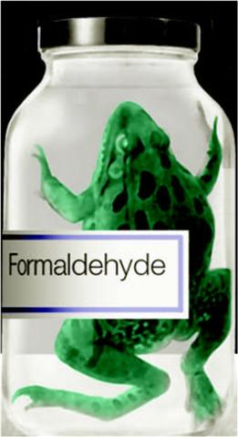
In addition, these compounds have very different properties and applications.
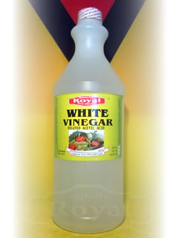
- The best way to identify an unknown compound is to determine its chemical formula.
- The subscripts in a chemical formula describe the number of atoms or ions of each element in the formula.

Distinguishing between Empirical Formula and Molecular Formula

- CH₂O is an example of an empirical formula.
- The empirical formula (EF) gives the simplest whole-number ratio of atoms or ions in a compound.
- Both formaldehyde and acetic acid have the same empirical formula: CH₂O.
- A molecular formula (MF) gives the exact number of each type of atom in a compound. (actual formula)

Ex., Benzene C₆H₆
EF = CH MF = C₆H₆

- Many compounds have molecular formula that are the same as empirical formula

Ex., NH₃ = EF = MF
Relationship between Molecular formula of a compound and Empirical formula is

Molecular formula subscripts = n x Empirical formula subscripts

MF = n x EF

where n = 1, 2, 3, (whole numbers)

Determining Empirical Formula

See Sample problem 1 See pages 111-113
Determining the Empirical Formula of a Compound a, b

Try Practice see page 114
Questions: # 1-2

See SUMMARY Steps Used to Determine an Empirical Formula See page 114

TIPS FOR SOLVING EMPIRICAL FORMULA PROBLEMS

1. Do not round-off the numbers until you have completed the calculation.
2. Decimal such as 0.80 to 0.99 can be rounded up to the nearest whole numbers.
3. Decimal such as 0.01 to 0.05 can be rounded down to the nearest whole number.
4. empirical formula is C_{1.5}H₃O₁ – convert all subscripts to whole numbers, multiply each subscript by 2, this gives C₃H₆O_{2.}

Determining the Molecular Formula

How clean is the air in your home?
Despite the best air-filtering technology available, indoor air pollution is unavoidable.
Most indoor pollutants come from one of two sources.
They are either produced by chemical processes in the home, such as home heating, or released – “off-gassed” – by products that we bring into the home.
A newly installed synthetic carpet, for example, releases a cocktail of volatile organic compounds (VOCs) into the air
Here are some mass spectrometer spectrums of “off-gasses”.
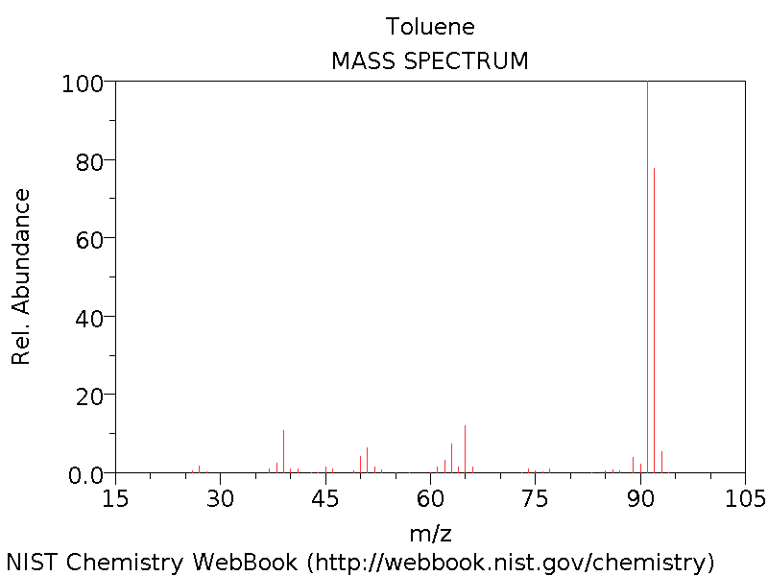
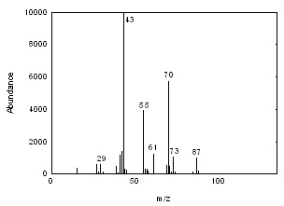

Determining Molecular Formulas

- Chemists find that the molecular formula of a compound is far more useful than an empirical formula.
- Determining the molecular formula from its empirical formula is an important step in analyzing an unknown compound.

Relationship between Molecular formula of a compound and Empirical formula is

Molar mass of a Molecular formula = n x Molar mass of a Empirical formula

M _{MF} = n x M _{EF}

where n = 1, 2, 3, (whole numbers)

n = M _{MF} / M _{EF}
See Sample Problem 2 a, b See pages 114-118

Try Practice see page 118
Questions: # 3-6

See SUMMARY – Steps Used to Determine a Molecular Formula
AND
Steps Used to Calculate Percentage Composition by Mass
See page 120

Try Section 2.3 Questions – see page 120
Questions # 1-7

Investigation

Percentage Composition of PopCorn

2.5 Quantitative Analysis:
Concentrations of Solutions

Something to Think About: See page 123

When a driver is asked …,

Quantitative Analysis

Concentrations of Solutions

- Dilute Solution: A solution that contains a small amount of solute relative to the amount that could dissolve.
- Concentrated Solution: solution that contains a large amount of solute relative to the amount that could dissolve.
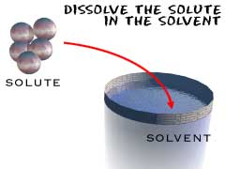
- Concentration: the ratio of the amount of solute per quantity of solvent.
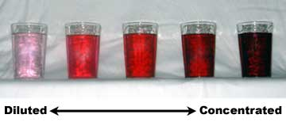
Percentage Concentration

- The concentration of solutions is sometimes expressed as percentages.
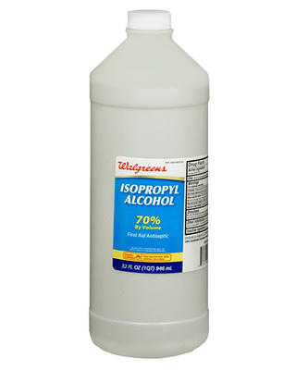
- Ex., vinegar is express as 5% V/V.
- Ex., rubbing alcohol as 10 V/V.

General Solution Formula:

c = quantity of solute
quantity of solution (solute + solvent)
c = concentration

- Percentage Volume/Volume (% V/V)

c _{v/v} = V solute X 100 %
V solution

- This form of expressing concentration is commonly used when both the solute and solutions are liquids.
- The unit for volumes must be the same for both solute and solution.
Ex., mL/mL, L/L

- Percentage Weight/Volume (% m/V)

c _{m/v} = m solute X 100 %
V solution

- The term “weight” on a product label actually refers to the mass of the solute.
- This form of expressing concentration is commonly used solid-liquid mixtures.
- The units can vary for both: mg/mL, g/L, kg/mL

- Percentage Weight/Weight (% W/W)

c _{w/w} = m solute X 100 %
m solution

- This form of expressing concentration is commonly used for solids in either liquids or other solids.
- The units can vary for both: mg/mg, g/g, kg/kg,t/t

See Sample Problem 1 – pages 125

Try Practice – pages 126
Questions: # 1-3

Molar Concentration

- Recall the term concentration and dilute.

- Chemists find it most convenient to express solution concentrations in terms of the amount (in moles) of solute per litre of solution.
- Traditionally, this was called the molar concentration or molarity of the solution, and used the unit symbol “M”.
- According to IUPAC, the governing body that regulates naming conventions in chemistry, the terms “molar concentration” and “molarity” are no longer correct.
- The amount concentration, c, of a solution is determined by dividing the amount (in moles) of solute, n, by the volume (in litres) of the solution, V:

Amount concentration (mol/L) = Amount of solute (mol)
Volume of solution (L)

This formula can be shortened to give;

c = n = mol
V L
n = c x V And V = n / c

Note: The volume of the solution is expressed in L
Note: 1000mL=1L
Note: moles expressed in mol

See Sample Problem 2-4 – pages 126-131

Try Practice – pages 126-131
Questions: # 4-7, 8-11, 12-15

Extremely Low Concentrations: Parts per Million and Parts per Billion

- Scientists working in the medical or environmental fields often measure concentrations that are extremely low.
- Expressing these concentrations as % m/m can give awkward numbers to work with.

- For this reason, very dilute concentrations are often expressed in parts per million (ppm, 1:10⁶), parts per billion (ppb, 1:10⁹), and even part per trillion (ppt, 1:10¹²).
Masses and Volumes of Very Dilute Solutions

- “Parts per” concentrations are actually a special case of % W/W concentrations.
- Since a very dilute aqueous solution is very similar to pure water its density is assumed to be 1 g/mL at 20⁰C.
- Therefore, a solute concentration of 1 ppm means that there is 1 g of solute in every 1 000 000 g or 1 000 000 mL of solution.
- This is a very small mass of solute per gram of solution:

c = $\frac{1 g solute}{1 000 000g solution}$

= 1 x 10⁻⁶ g solute/g solution

- To make this number more convenient to work with, chemists multiply it by 10⁶ to define a ppm.

Parts per million (ppm) Parts per billion (ppb) Parts per trillion (ppt)
Ex., 1 drop in a bathtub Ex., 1 drop in a swimming pool Ex., 1 drop in a 100 swimming pools

c _{ppm} = m solute _{X 10}⁶ c _{ppb} = m solute _{X 10}⁹ c _{ppt} = m solute _{X 10}¹²
m solution m solution m solution

When the solvent is water, we can use several units for these concentrations:

NOTE: 1 g = 1000 mg AND 1000mL = 1 L

1 ppm = 1 g/10⁶ g 1 ppb = 1 g/10⁹ 1 ppt = 1 g/10¹²

= 1 g/10⁶ mL = 1 g/10⁶ L = 1 g/10⁹L

= 1 g/1000 L = 1 mg/1000 L = 1 mg/10⁶ L

= 1 mg/L
1 ppm = 1mg/L

When solving problems, select the unit that best matches the information in the problem
See Sample Problem 5– pages 132-133

Try Practice – page 131
Questions: # 16-18

See SUMMARY – Concentrations of Solution Equations
See page 133

Diluting Aqueous Solutions

- Many dilute solutions can be prepared by simply applying some common sense.
- For example, a doubling the volume of the solution by adding water decreases its concentration by a factor of 2.
- For less obvious situations, we need to develop a mathematical equation that can be used to determine the final concentration of the dilute solution.
- Dilution is the process of decreasing the concentration of a solution by adding more solvent.
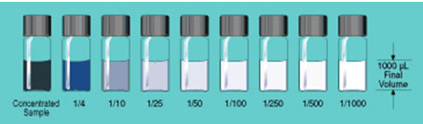
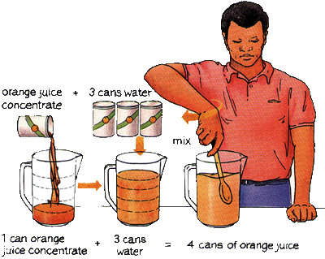
During dilution, the amount (in moles) of solute present does not change.
As the concentration of a solution decreases due to an increase of its volume.
The amount of solute remains unchanged.

The moles of solute in the final dilute solution = moles of solute taken from the concentrated solution.

Dilution formula:
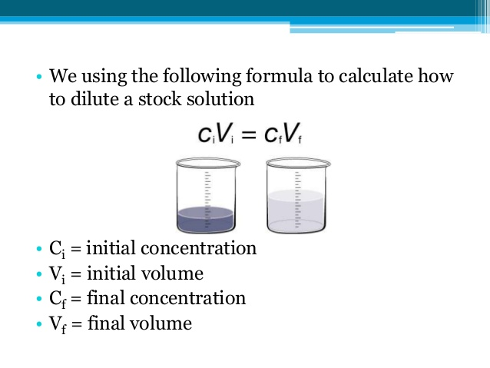
where: C_{i} = initial concentration (mol/L) C_{f} = final concentration (mol/L)

V_{i} = initial volume (L) V_{f} = final volume (L)

NOTE: UNITS for c MUST be in mol/L AND V must be in L
C_{i} › C_{f}

See Sample Problem 6– pages 134-136
Try Practice – page 136
Questions: # 19-22
Try Section 2.5 Questions page 137
Questions: 1-6

2.9 The Mole and Chemical Equations:
Stoichiometry

Determining Ratios from Balanced Chemical Equations

- A chemical equation is similar to a recipe, with the chemical formulas indicating the “ingredients” of the reaction.
- The coefficients in the equation give the ratio of one chemical to another chemical used in the equation.
- However, these are ratios of numbers of entities rather than masses.

1N_{2(g)} + 3H_{2(g)} → 2NH_{3(g)}

- you can use a ratio to express the number of atoms in the equation, as follows:

1 molecule N_{2:} 3 molecules H_{2:} 2 molecules NH₃

1N_{2(g)} | 3H_{2(g)} | 2NH_{3(g)}
Number of molecules | Number of molecules | Number of molecules
1 | 3 | 2
5 | 15 | 10
100 | 300 | 200
1 x 6.02x10²³= 1 mol | 3 x 6.02x10²³= 3 mol | 2 x 6.02x10²³= 2 mol

- The ratio of the amount (in moles) of one chemical to another in a chemical equation is called the mole ratio.

- Ex., Decomposition of Water

Mass Relationships in Chemical Equations

Masses and Chemical Equations

- The coefficients of a balanced chemical equation give the mole ratio of one chemical to another.
- These values give the relative amount of one chemical required to react with another.
- They can also be used to predict the amount of product expected.
- The study of the mass and amount relationships between reactants and products in a chemical reaction is stoichiometry.

Stoichiometry Amounts

- A stoichiometric amount is the predicted amount of a reactant, relative to another reactant, that will react according to the balanced chemical equation.
- The amounts of reactants consumed are in the same proportion as the coefficients in the balanced chemical equation.
- When stoichiometric amounts of reactants are available for a chemical reaction, no reactants should remain when the reaction is complete.

This assumes that the reaction proceeds to completion

A General Process for Solving Stoichiometric Problems

Step 1: Write a balanced chemical equation – write ALL given information

Step 2: If you are given the mass or number of particles of a substance; convert it to the number of moles

Step 3: Calculate the number of moles of the required substance based on the number of moles of the given substance, using the appropriate mole ratio

Step 4: Convert the number of moles of the required substance to mass or number of particles, as directed by the equation

When Calculating Molar Mass (M)
Do Not USE the Coefficient
Ex., 2H₂ +
_{1.01g/mol x 2= 2.02g/mol}
_{NOT}
_{1.01g/mol x 2 x 2=4.04g/mol}

See Sample Problem 1-2– pages 145-146

Try Practice – page 148
Questions: # 1-3

Try Section 2.9 Questions page 148
Questions: # 1-5

2.10 Limiting and Excess Reagents

Which Reagent Runs Out First?

- Carefully measuring stoichiometric amounts of each reactant is tedious and often impractical.
- Usually, one of the reactants is used up first.
- The reactant that is completely used up is called the limiting reagent (LR).
- When this reactant runs out, the reaction stops.
- Some of the other reactants are left over.

In other words, the limiting reactant determines how much product is produced

- The excess reagent (ER) is the substance that is present in a larger quantity than is required.
- Some of the excess reagent is left over after the reaction.
- There can only be ONE limiting reagent in a reaction but there could be more one excess reagent.

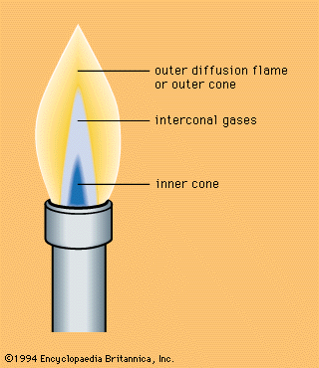
- Examples:

Limiting Reagent Problems Involving Amounts

- If you are given quantities of two different reactants, you first have to figure out which one is the limiting reagent.
- You can then use this amount to predict what amount product will be produced.

Limiting Reagent Problems Involving Masses

- Follow the flow chart

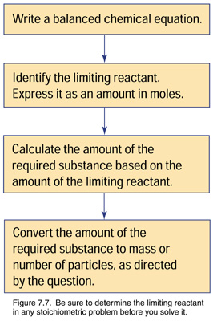

See Sample Problem 1– pages 151-153

Try Practice – page 153
Questions: # 1-4

Try Section 2.10 Questions page 153
Questions: #1-6

2.12 Percentage Yield

Reaction Yield

- Imagine a chemical reaction with a limiting reagent.
- Ideally, the entire limiting reagent is converted into the desired product.
- This gives the maximum possible yield of product and is defined as the theoretical yield for the reaction.
- The amount of product that is predicted by stoichiometry is called the theoretical yield (TY)
- The theoretical yield is achieved if 100% of the limiting reagent is converted into products.
- Chemists can predict the theoretical yield before observing the reaction.
- You predicted the theoretical yields in section 7.4, when you calculated the amount or the mass of product that could be produced.
- In practice, however, theoretical yields are rarely achieved.
- Instead, the actual yield (AY) – the amount of the product collected during an experiment or industrial process – is usually less.
- This means that some of the LR did not become part of the collected product.

Why Actual Yield and Theoretical Yield are often different?

- The actual yield of chemical reactions is usually less than the theoretical yield is because of several factors;

- Experimental procedure – List some?

- Completing reaction – a reaction that occurs at the same time as the principal reaction and involves its reactants and/or product

- Impurities – the chemicals used in investigations are rarely 100% pure.
In fact, they come in a wide range of grades (or purities)

Percentage Yield

- The percentage yield of a chemical reaction compares the mass of product obtained by experiment (the actual yield) with the mass of product determined by stoichiometric calculations (the theoretical yield)

Percentage yield = (Actual yield/Theoretical yield) x 100%

AY=TY= SAME MASS UNITS
g/g OR Kg/Kg

See Sample Problem 1– pages 156-157

Try Practice – page 158
Questions: # 1-4

Try Section 2.12 Questions page 159
Questions: #1-4

2.13 Investigation
The Percentage Yield of a Chemical Reaction

UNIT 2 SUMMARY

Be Familiar with; Key Terms on pages 165

Be Familiar with; Problems You Can Solve page 165

UNIT 2 REVIEW Question’s: pages 169-171
Try questions: #1-20

